Association of Renal Technologists AGM Meeting
3rd October 2024
The Telford Hotel

- Available attendees:
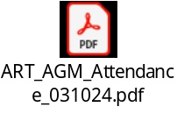

- Apologies:
None

- Agreement of Agenda and notification of Any Other Business not covered:
None tabled.

- Minutes of last meeting: 29th April 2024, acceptance for accuracy:
Accepted by all members.

- Action Plan and work in progress:
See Action Plan attached separately

- Chairman’s Report:
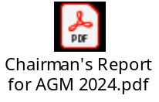

- Treasurers report:


- Website Report including website updates:
No new update

- ART Ed Group and Training Scheme:
22 Trainees 1 on the old scheme.
UWE need more teachers to come forward from ART members

- SLWG – GB:
Disappointing uptake.
Looking forward to more people being involved
Less senior members to more involved in the protection systems in HD machines etc.
Water guidelines – Nic Hoenich :-
Reviewing 23500 all sections to be published soon, the RA guidelines on water treatment members to comment,

- Election of EC Members:
Roger Moore (RM): Happy to continue ALL members approved
Peter Jones (PJ): Happy to continue ALL members approved but this will be last time PJ stands for re-election due to pending retirement.

- Proposals received from the Membership:
None tabled

- Any Other Business:
Saravan: Will jobs still be feed to website?
Yes
John(Portsmouth): Job descriptions to be discussed

OP: When job advertised, could successful candidate post on ART website? This could be a breached of GDPR?
GB: Banding of posts to discuss.

Marius: Expressed interest in joining EC Committee.

- Close:

